**ASSIGNMENT 1:**

**CREATE A FLOWCHART/DIAGRAM ILLUSTRATING THE SDLC AND IT’S STAGES.**

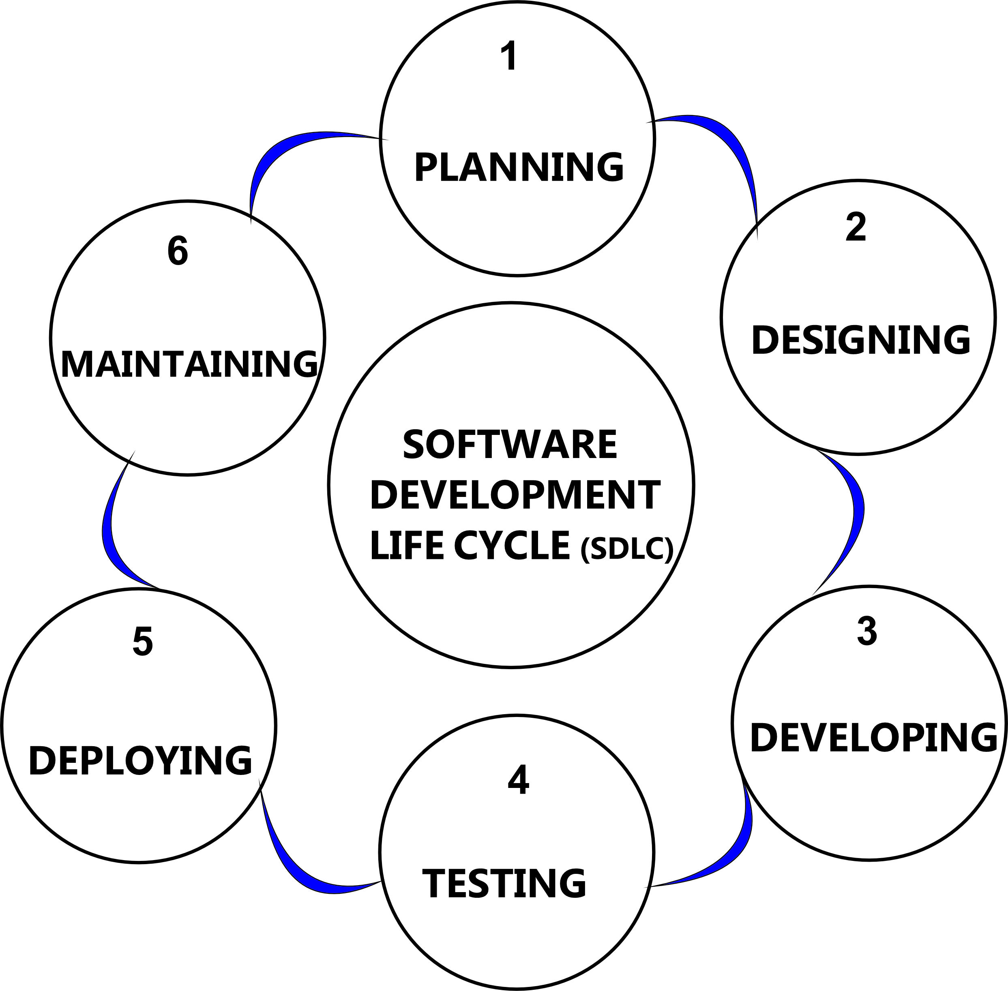

**ASSIGNMENT 2:**

**Write a short essay explaining the purpose and activities of each SDLC stage.**

The Software Development Life Cycle (SDLC) is a step-by-step process to develop high-quality software delivered efficiently and effectively to meet a client’s business requirement, structured to outline the stages involved in the development of software applications. The SDLC is divided into several stages, each with its purpose and activities.

1. **Planning:**

**Purpose**: The planning stage is first stage of the SDLC essential for defining the objectives and scope of the project. It involves identifying the resources required, gathering them, analyzing/ estimating costs, documenting them and setting timelines.

**Activities**:

* Gathering initial requirements from stakeholders, discussing what the software should do and why it’s needed.
* Conducting feasibility studies to determine technical and financial viability, figuring out the cost, resources, and time required.
* Developing a project plan that outlines tasks, schedules, resources, and risk management strategies needed to complete the project.

2. **Design**

**Purpose**: The design stage is second stage of the SDLC, showing how the software will look like and work. The design stage transforms the requirements into a framework for building the software, including architecture, user interfaces, and data models.

**Activities**:

* Creating diagrams, patterns and models that outline the overall structure and components of the software to show how the software will be organized.
* Designing the user interfaces, deciding how it will look and how users will interact with it for easy usability and accessibility.
* Developing detailed database design, flow charts to map out data interactions and how data will be managed within the software.

3. **Development (Building)**

Purpose: The development stage is third stage of the SDLC where the actual coding takes place once the design document is completed. The software is built according to the design specifications by writing and assigning codes.

**Activities**:

* Programmers /developers write the code based on the design documents and assign coding tasks in the chosen programming languages.
* Combining different parts modules and components of the software to make sure they work well together.

4. **Testing**

**Purpose**: The testing stage is fourth stage of the SDLC to check that the software works correctly and is free of bugs.

**Activities**:

* Running different tests either by checking individual parts (units) of the software to make sure they work as expected.
* Testing the Whole System by running the software as a whole to see how well all the parts work together.
* Fixing any problems or bugs found during testing.
* Get feedback from real users to ensure the software meets the needs defined in the requirements.

5. **Deployment**

**Purpose**: The deployment stage is fifth stage of the SDLC to release the finished software to users, making it available on the website, mobile device app store, or a software distribution server on a corporate network.

**Activities**:

* Installing the Software: Set up the software on users’ computers or servers, or make it available online.
* Training Users: Teach users how to use the software effectively and providing support if needed.
* Launching: Officially release the software to the public or within the organization.
* Checking everything works properly in the real-world environment

6. **Maintenance**

**Purpose**: The maintenance stage is sixth stage of the SDLC to keep the software running smoothly after it’s been released.

**Activities**:

* Monitoring the software to ensure it’s working as intended.
* Fixing any issues that come up after deployment.
* Updating the software with new features or improvements based on user feedback.